|  |  |  |  |  |  |
| --- | --- | --- | --- | --- | --- |
| Str +2 | Dex 0 | Con 2 | Int 0 | Wis 0 | Cha +4 |

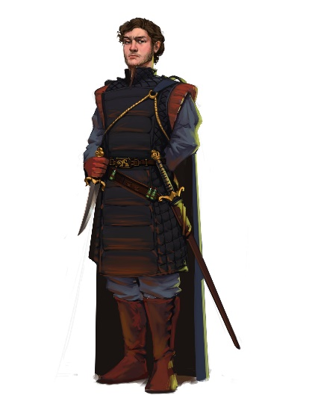

**MARKIN TOURPAN** (Lawful Good)

AC: 16

Speed: 30

HP: 33 _________________

--------------------------------------------

Passive Perception: 13

Saving Throws: Str +4

Skill Proficiencies: Persuasion +6

--------------------------------------------

Attack: +4 (Piercing)

Damage: Short Sword (1d6+3)

|  |  |  |  |  |  |
| --- | --- | --- | --- | --- | --- |
| Str +1 | Dex +4 | Con +2 | Int +3 | Wis 0 | Cha -1 |

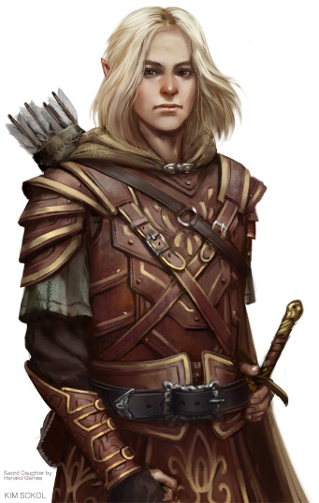**Hadari Moongaze** (Chaotic Good)

AC: 16

Speed: 30

HP: 45 _________________

--------------------------------------------

Passive Perception: 14

Saving Throws: Dex +7

Skill Proficiencies: Investigation +6,

Stealth +7

--------------------------------------------

Attack: +4

Damage: Short Sword (1d6+4) (P)

Damage: Long Bow (1d8+4) (P)

|  |  |  |  |  |  |
| --- | --- | --- | --- | --- | --- |
| Str +2 | Dex +0 | Con +1 | Int +1 | Wis 0 | Cha 2 |

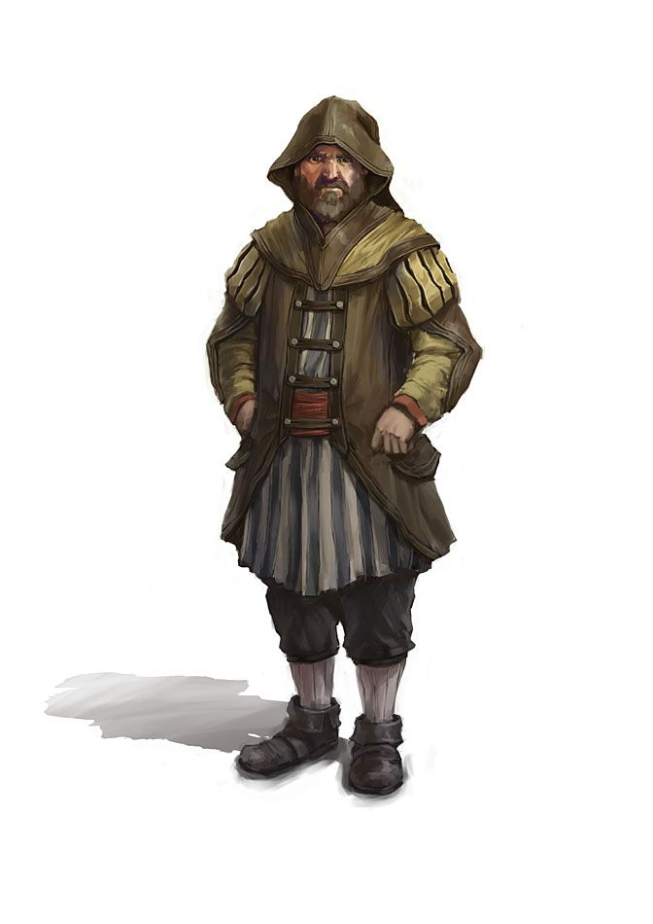

**Targulm Haven** (Lawful Neutral)

AC: 15

Speed: 30

HP: 25 _________________

--------------------------------------------

Passive Perception: 13

Saving Throws: Cha +4

Skill Proficiencies: Intimidation +4,

--------------------------------------------

Attack: +4

Damage: Hand Axe (1d6+2) (S)

|  |  |  |  |  |  |
| --- | --- | --- | --- | --- | --- |
| Str 10 | Dex 5 | Con 3 | Int -10 | Wis -10 | Cha 2 |

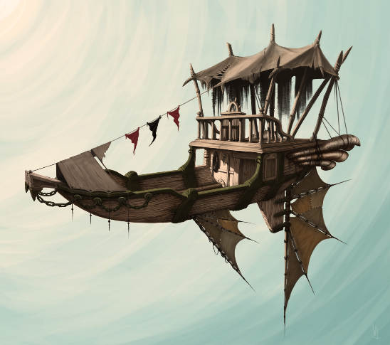Air Ship (Unaligned)

AC: 15

Speed Flying: 100

Speed Water: 50

HP: 892 _________________

-------------------------------------------

Passive Perception: 0

Saving Throws: +4

Skill Proficiencies: Intimidation +10,

Immunities: Poison, Cold, Psychic, Cold

Vulnerabilities: Fire, Acid

**Cargo:** This ship can carry up to 1000lbs of additional cargo without effect. This weight excludes starting crew, weapons, and equipment. If the cargo exceeds 1000lbs the ship cannot not climb. At 1100lbs the ship will start to drop at a speed of 5 (plus an additional 5 for every 100lbs).

**Nitrous Boost.** Once per day you can add Nitrous to your motor to give you a speed boost to 300 for 10 minutes. After 10 minutes the ship must make a DC 10 saving throw every minute or damage the Terrastone or the motor (50/50). The boost speed is limited to 200 if the cargo is within 10% of its max limit and can be used to keep the ship aloft for 10 minutes if cargo is above the max limit up to 1500lbs.

**Dive**: 2 times per day, the ship can completely cut its motor and go into a controlled dive. When this feature is implemented the ship can dive faster than a person can fall, so individuals or equipment on the deck would need to be restrained or potentially fall off the deck. Any person on the deck who is not strapped in or holding on to something stationary would need to make a DC 10 dexterity saving throw or be thrown from the ship.

**Silent Hover:** At any time the ships motors can go into a ultra-quite state. To take advantage of this feature the ship needs to be moving at a speed of 10 or less and not be climbing at speed greater than 5. This feature **can not** be applied at if the ships cargo is within 10% of its max limit.

**Grapple**: If the ship has a grappling hook, the hook can be thrown a distance up to the throwers strength multiplied by 3.

If the object or creature does not want to be hooked, it must succeed a DC 13 Dexterity Saving Throw or be caught by the ship. In addition, at the start of the object or creatures turn it must make a DC 13 Strength saving throw to become engrappled, if the object or creature weight is above 500lbs than the rope has a 50% chance it will break.

Cannon: